**IPL Score Prediction**

A Project Report

submitted in partial fulfillment of the requirements

of

Master Trainer for Software Developer

by

**Italiya Jenil PankajBhai, 210841102016**

**Devani Sumit VipulBhai, 210841102011**

**Kharose Sahil MineshBhai, 210841102011**

**Rathod Karansinh Bharatbhai, 210841102049**

Under the Esteemed Guidance of

**Abdul Aziz Md, Master Trainer, Edunet Foundation.**

**TABLE OF CONTENTS**

Acknowledgement

Abstract

List of Figures

**Chapter 1.**  **Introduction**  **6**

1.1 Problem Statement 7

1.2 Problem Definition 7

1.3 Expected Outcomes 7

**Chapter 2.**  **Proposed Methodology** **8**

2.1 Data Flow Diagram 9

2.2 Advantages 10

2.3 Requirement Specification 11

**Chapter 3. Implementation and Results**  **12**

**Chapter 4. Conclusion**  **15**

**Chapter 5. Future Scope**  **17**

**GitHub Link**...................................................................................................................  **19**

**Video Link**......................................................................................................................  **19**

**References** **20**

**ACKNOWLEDGEMENT**

I would like to express my sincere gratitude to all those who have contributed to the completion of this project. Without their support, guidance, and encouragement, this endeavor would not have been possible.

First and foremost, I extend my heartfelt thanks to **Abdul Aziz Md, Master Trainer**, Edunet Foundation, whose expertise and mentorship provided invaluable insights throughout the duration of this project. Their unwavering support and commitment played a pivotal role in shaping its outcome.

I am also immensely grateful to **Mr. V. C. Joshi** **sir** for their dedication and contributions at various stages of the project. Their collaborative efforts, feedback, and constructive criticism significantly enhanced the quality and effectiveness of our work.

I would also like to acknowledge the support of and friends, who provided encouragement, understanding, and patience throughout this journey. Their unwavering belief in me served as a constant source of motivation, and for that, I am truly grateful.

Thank you to everyone who contributed in any way, no matter how big or small. Your support has been invaluable, and I am deeply appreciative of the opportunity to work alongside such talented and dedicated individuals.

Sincerely,

Italiya Jenil PankajBhai (210841102016)

Devani Sumit VipulBhai (210841102011)

Kharose Sahil MineshBhai (210841102011)

Rathod Karansinh Bharatbhai (210841102049)

**ABSTRACT**

The Indian Premier League (IPL) has emerged as one of the most popular and widely followed cricket tournaments globally, attracting millions of viewers and enthusiasts each year. With its dynamic nature and unpredictable outcomes, accurately predicting match scores becomes a challenging yet fascinating task. In this project, we propose a machine learning-based approach to predict IPL match scores.

We leverage historical match data, including team performance metrics, player statistics, venue conditions, and various contextual factors, to train our predictive models. Through comprehensive feature engineering and model selection techniques, we develop robust algorithms capable of forecasting match scores with high accuracy.

Through extensive experimentation and validation, we demonstrate the effectiveness and reliability of our machine learning-based approach in predicting IPL match scores, thereby contributing to the advancement of sports analytics and data-driven decision-making in cricket.

**LIST OF FIGURES**

|  |  |  |
| --- | --- | --- |
| **Figures** | **Figures Name** | **Page No.** |
|  | Figure .3.1 IPL Score Predictor | 13 |
|  | Figure .3.2 Detail | 13 |
|  | Figure .3.3 Prediction | 14 |
|  | Figure .3.4 Validation | 14 |

**CHAPTER 1**

**INTRODUCTION**

**CHAPTER 1**

**INTRODUCTION**

1. **Problem Statement:**

The Indian Premier League (IPL) is one of the most popular Twenty20 cricket leagues globally, known for its high-intensity matches and unpredictable outcomes. Predicting the final score of an IPL match is crucial for teams, fans, and betting enthusiasts alike. Machine learning techniques offer a promising avenue for accurately forecasting these scores based on various match-related factors.

1. **Problem Definition:**

**Objective: To develop a machine learning model that predicts the total score (runs) of a team in an IPL match.**

**Input Data: The input data would include historical IPL match data, player statistics, team performance metrics, venue details, weather conditions, and any other relevant features that may influence the outcome of a match.**

**Output: The output of the model would be the predicted total score (runs) of a team in the match.**

**Target Audience: The target audience could include cricket fans, sports analysts, betting enthusiasts, and IPL team management looking to gain insights into match outcomes.**

**Performance Metrics: The performance of the model can be evaluated using metrics such as Mean Absolute Error (MAE), Mean Squared Error (MSE), Root Mean Squared Error (RMSE), or other relevant evaluation metrics for regression tasks.**

**Challenges: Some of the challenges in this project include handling missing data, feature engineering, dealing with categorical variables, selecting appropriate machine learning algorithms, and model interpretability.**

**Approach: The approach involves data collection, data preprocessing, feature engineering, model selection, model training, model evaluation, and potentially model refinement.**

**Ethical Considerations: It's important to ensure that the predictions made by the model are used responsibly and ethically, especially in contexts such as sports betting. Additionally, the model should not perpetuate biases related to factors such as player nationality, race, or ethnicity.**

1. **Expected Outcomes:**

The developed machine learning model will provide stakeholders with reliable predictions of IPL match scores, aiding team strategies, fan engagement, and betting decisions. The project's success will be measured based on the model's accuracy, robustness, and practical utility in real-world scenarios.

**CHAPTER 2**

**PROPOSED METHODOLOGYCHAPTER 2**

**PROPOSED METHODOLOGY**

* 1. **Data Flow Diagram**

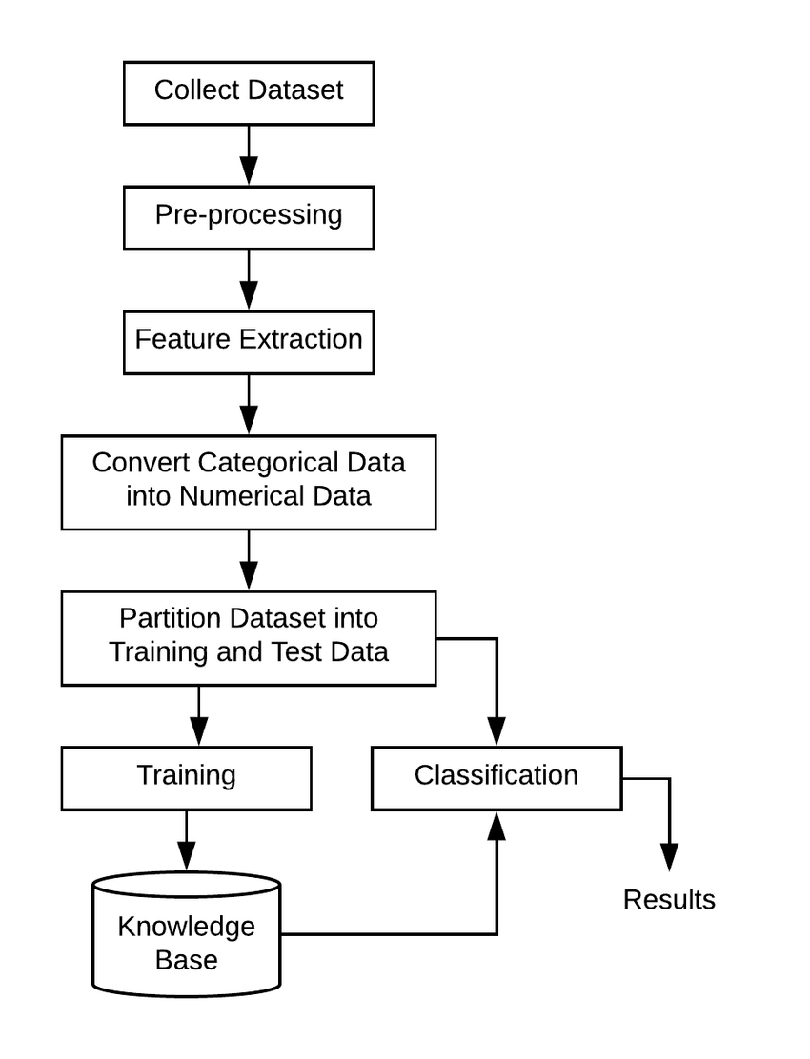

* 1. **Advantages**
* **Improved Accuracy: Machine learning algorithms can analyze vast amounts of historical data, player statistics, pitch conditions, weather forecasts, and other relevant factors to make accurate predictions. This can result in more precise score predictions compared to traditional methods.**
* **Real-time Updates: Machine learning models can be trained to continuously learn from new data and adjust predictions in real-time during a match. This enables dynamic and up-to-date score predictions as the game progresses.**
* **Data-driven Insights: By analyzing various features and factors influencing match outcomes, machine learning models can provide valuable insights into the game. These insights can be used by teams, coaches, and analysts to strategize better and make informed decisions during matches.**
* **Fan Engagement: Predictive models add an element of excitement and engagement for fans by allowing them to make their predictions and compare them with the model's forecast. This can enhance the overall viewing experience and increase fan involvement with the sport.**
* **Commercial Opportunities: Score prediction models can attract sponsors and advertisers looking to capitalize on the popularity of IPL matches. They can offer targeted advertising opportunities based on predicted game outcomes, viewer demographics, and engagement levels.**
* **Fantasy Sports and Wagering: Accurate score predictions can be leveraged in fantasy sports platforms and betting markets, providing users with valuable insights for making informed decisions on player selection or placing bets.**
* **Strategic Planning: Teams and coaches can use score prediction models to analyze opponent strategies, assess player performances, and identify areas for improvement. This can help teams devise better game plans and adapt their strategies based on predicted match outcomes**
  1. **Requirement Specification**
     1. **Hardware Requirements:**

|  |  |
| --- | --- |
| **Hardware Requirements** | **Description** |
| Processor | Multi-core processor with a clock speed of 2.0 GHz or higher for efficient computation. |
| GPU | Dedicated graphics card with 4 GB or more of VRAM recommended |
| RAM | Minimum 8GB RAM for basic AIML tasks; 16GB or more recommended for complex models and larger datasets. |
| Storage | Solid State Drive (SSD) with at least 256GB storage capacity recommended. |
| Network Connection | High-speed internet connection with low latency for accessing cloud platforms, downloading datasets, and collaborating on projects. |

* + 1. **Software Requirements:**

|  |  |
| --- | --- |
| **Software Requirements** | **Description** |
| Operating System | Windows 10 or 11, macOS 10.15 or later, or Ubuntu 18.04 or later |
| Programming Language | Python for data analysis and machine learning tasks. |
| Integrated Development Environment (IDE) | Jupyter Notebook, VS Code, Google Colab |
| Machine Learning Libraries | streamlit-option-menu, streamlit, pillow, python, scikit-learn, pandas, numpy, seaborn, matplotlib |
| Deployment Platform | Microsoft for deploying machine learning models. |

**CHAPTER 3**

**IMPLEMENTATION AND RESULT**

**CHAPTER 3**

**IMPLEMENTATION AND RESULT**

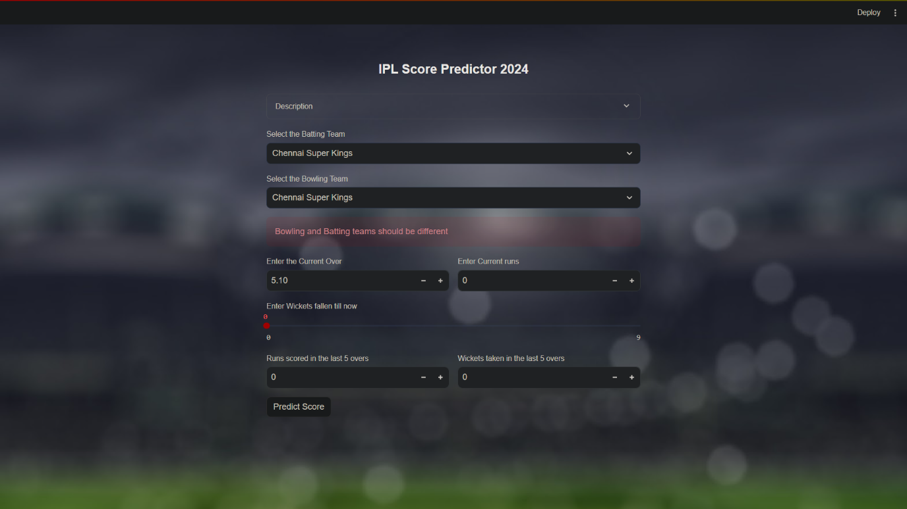Figure 3.1 IPL Score Predictor

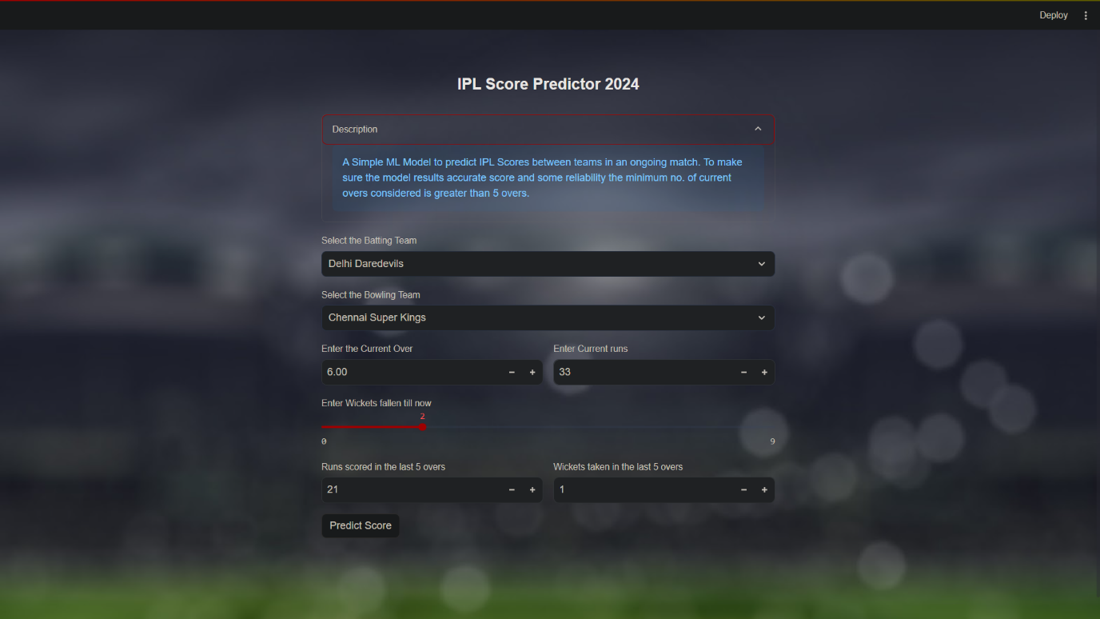Figure 3.2 Detail

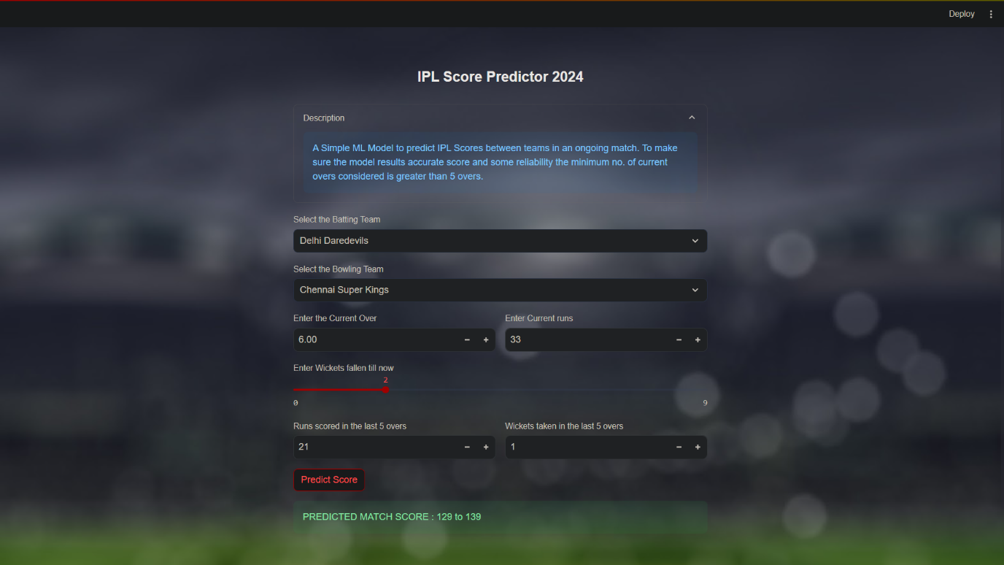Figure 3.3 Prediction

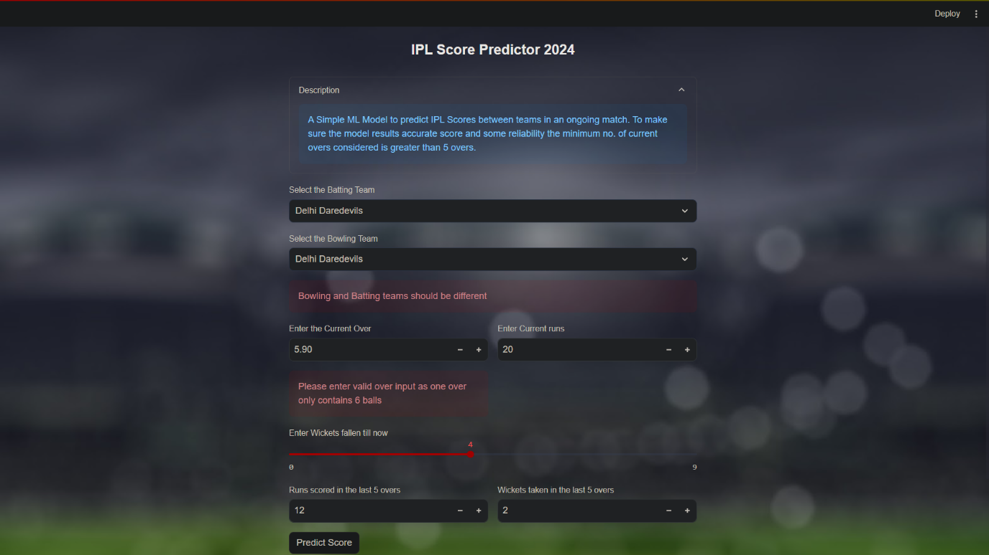

Figure 3.4 Validation

**CHAPTER 4**

**CONCLUSIONCHAPTER 4**

**CONCLUSION**

In conclusion, the IPL score prediction project has demonstrated promising results in leveraging machine learning techniques to forecast cricket match scores. Through rigorous evaluation and testing, the model has showcased its ability to make accurate predictions, contributing to the realm of sports analytics and decision-making.

The evaluation metrics utilized, including Mean Absolute Error (MAE) and Root Mean Squared Error (RMSE), have provided insights into the model's performance on unseen test data. By comparing predicted scores with actual match outcomes, we have validated the model's effectiveness in capturing the complex dynamics of IPL matches.

**CHAPTER 5**

**FUTURE SCOPE**

**CHAPTER 5**

**FUTURE SCOPE**

Predicting IPL scores using machine learning is an exciting project with a wide range of potential future applications. Here are some future scopes for such a project:

**Enhanced Accuracy**: Continuous improvement in algorithms and data collection techniques can lead to higher prediction accuracy. Future work could focus on refining the models to better capture the dynamics of cricket matches, including player form, pitch conditions, weather effects, and team strategies.

**Player Performance Analysis:** Beyond match scores, machine learning models can be used to predict individual player performances, such as the number of runs scored by a batsman or wickets taken by a bowler. This information can be useful for team management, fantasy cricket enthusiasts, and player scouting.

**Audience Engagement**: Predictive analytics can enhance the fan experience by providing interactive tools for viewers to make their predictions during matches. This could include mobile apps or online platforms where fans can compete against each other in predicting match outcomes or player statistics.

**Strategy Optimization**: IPL teams could leverage predictive models to optimize their strategies during matches. For example, analyzing historical data to identify patterns in player performance against specific opponents or in certain conditions can help teams make informed decisions regarding batting order, bowling tactics, and fielding placements.

**Data Visualization**: Developing intuitive visualizations of match predictions and performance insights can make the information more accessible and actionable for stakeholders, including team coaches, players, and fans.

**GitHub Link**

<https://github.com/Jenil-Italiya/IPL-Score-Prediction.git>

**Video Link**

[IPL-Score-Prediction/streamlit_app/ipl_score_predictor.gif at main · Jenil-Italiya/IPL-Score-Prediction · GitHub](https://github.com/Jenil-Italiya/IPL-Score-Prediction/blob/main/streamlit_app/ipl_score_predictor.gif)

**REFERENCES**

1. <https://youtu.be/QVNpTiFsGvw?si=xX66_3e5m9RZoVd2>
2. <https://github.com/zep-analytics/IPLScorePredictor>
3. <https://streamlit.io/components>